Measurement Protocol PAX

# General Information:

|  |  |  |
| --- | --- | --- |
| Test date: 14/02/20 | Date prev. test: | Test number: 1 |
| Tested by: Alex Pollak | PAX number: PB-013 | Installed at ant.: 2A |
| Comments: Revision: 1.10 pax controller | | |
|  | | |
|  | | |
|  | | |
| Known problems: Bumpy Y passband and Y saturates at 1.7dBm on noise measurement | | |
|  | | |
|  | | |
|  | | |

# Setup:

|  |  |  |  |
| --- | --- | --- | --- |
| Power supply: | OK 🗹 NOK 🗆 | Communication: | OK 🗹 NOK 🗆 |
| Supply current +6V: 1.118A | | ssh obs@antcntl | |
| Supply current -6V: 0.120A | | ssh ataant@paxtester | pw: q@n@t |
| Supply current +5V: 0.256A | | telnet pax | “help” |
|  | | CTRL + ] | “close” |

# RF Test with VNA:

### VNA Setup:

|  |  |  |
| --- | --- | --- |
| Load configuration: Passband_PAX.csa | | |
| Freq Start: 1.0 GHz | Freq Stop: 13.0 GHz | Power Level: -20 dBm |
| Averaging: enabled | Averaging count: 15 | N. Points: 801 |
| VNA : Agilent N5230C 10MHz - 20GHz | | |

|  |  |  |  |  |
| --- | --- | --- | --- | --- |
| VNA to PAX connection: | 1m ABC-CA18 Cable + 20dB Attenuator | | | |
| Input Power Level to PAX: (Measured) | @1GHz:  -40.2dBm | @4GHz:  -40.7dBm | @8GHz: -41.2dBm | @12GHz: -41.4dBm |

|  |  |
| --- | --- |
| PAX to VNA connection: | 2m Fibre Cable + Fibre Diode + AOX Amplifier + 1m ABC-CA18 Cable |

### Measured Passband with Attenuator set to 7dB each (Complete Link):

|  |
| --- |
| X |

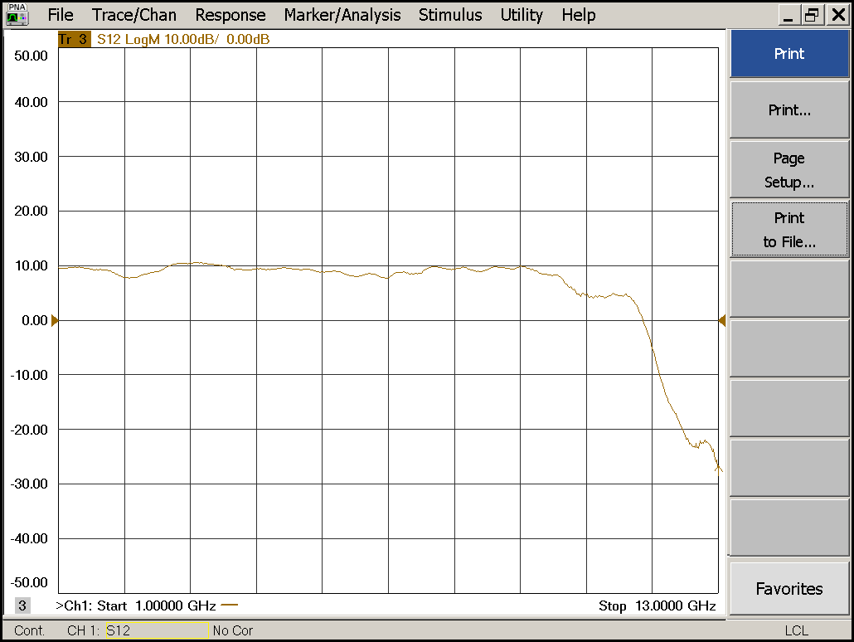

|  |  |  |  |
| --- | --- | --- | --- |
| Flatness: | OK 🗹 NOK 🗆 | Unwanted Features: | Yes 🗆 No 🗹 |

|  |
| --- |
| Y |

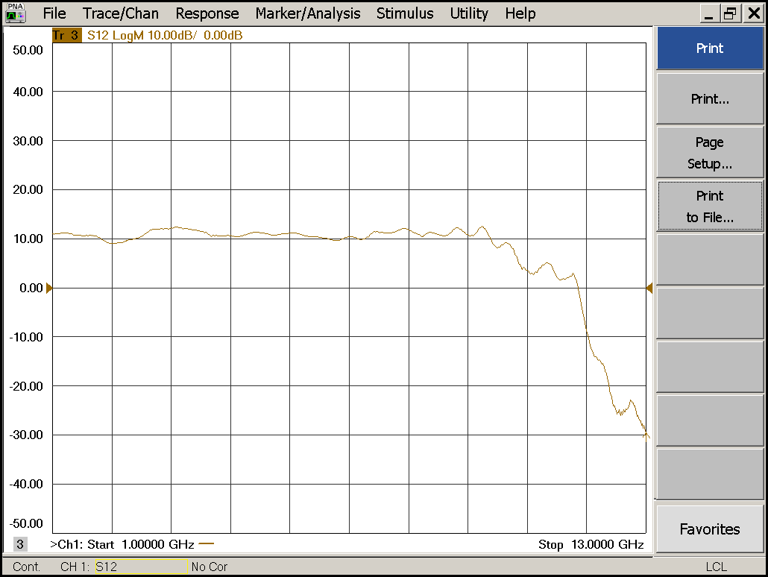

|  |  |  |  |
| --- | --- | --- | --- |
| Flatness: | OK 🗹 NOK 🗆 | Unwanted Features: | Yes 🗆 No 🗹 |

### Power Sweep (Complete Link):

|  |  |  |
| --- | --- | --- |
| Load configuration: Power_Sweep_PAX.csa | | |
| Power Start: -40dBm | Power Stop: -20dBm | Frequency : 4.0GHz |
| PAM Attenuator: 0dB |  | N. Points: 801 |

|  |
| --- |
| X |

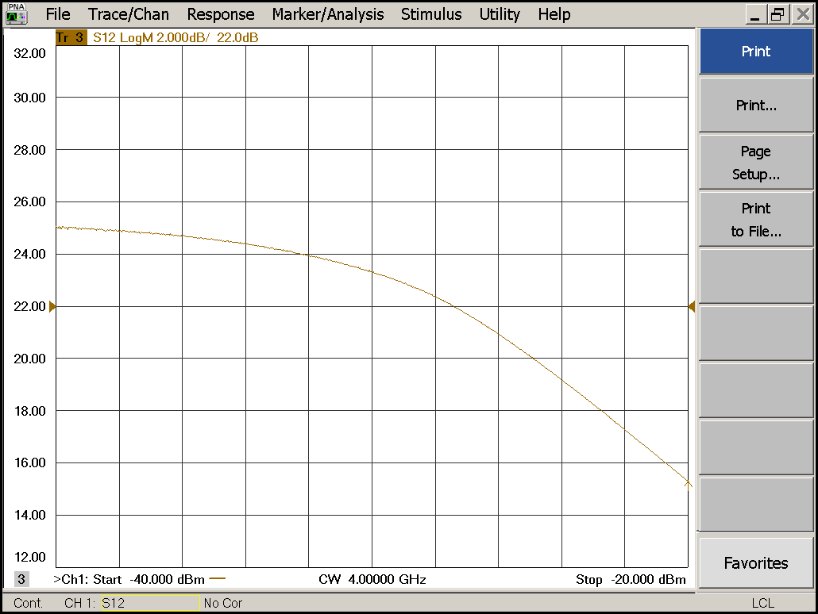

|  |  |  |  |
| --- | --- | --- | --- |
| Compression point: | OK 🗹 NOK 🗆 | Unwanted Features: | Yes 🗆 No 🗹 |

|  |
| --- |
| Y |

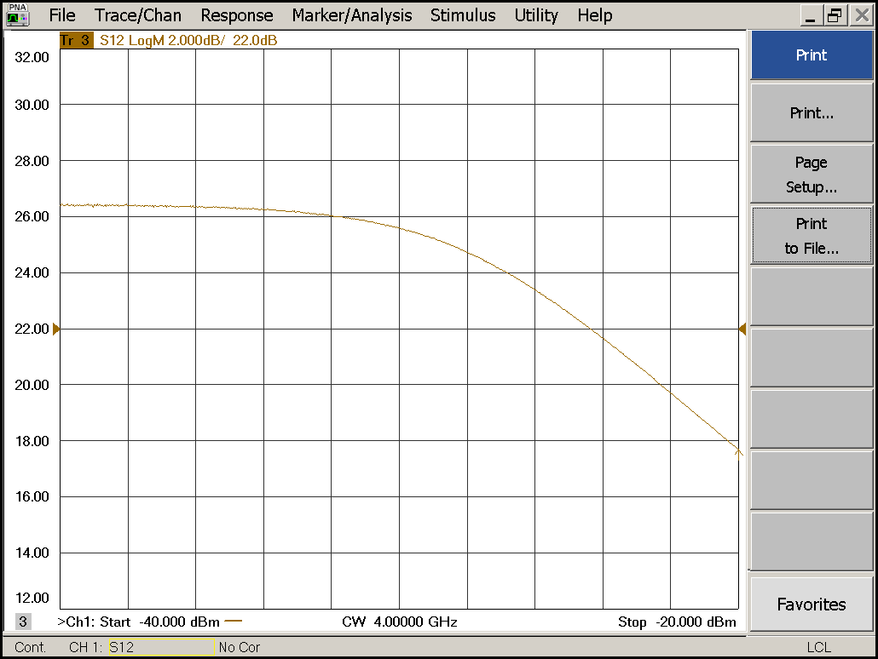

|  |  |  |  |
| --- | --- | --- | --- |
| Compression point: | OK 🗹 NOK 🗆 | Unwanted Features: | Yes 🗆 No 🗹 |

### Detector Calibration and Attenuator Sweep Pol X:

|  |  |  |
| --- | --- | --- |
| Load configuration: Detector_Calibration_PAX.csa | | |
| Freq : 4.0 GHz | Power Level: -20dBm | Sweep Time: -20sec |
| Sweep Mode: CW | Power Level at PAX Input (Measured): -40.6dBm | |

|  |  |  |  |  |
| --- | --- | --- | --- | --- |
| X | | | | |
| CW Input Power [dBm]: | Attenuator Value A [dB]: | Attenuator Value: B [dB]: | Detector Value: | Power Meter  Value [dBm]: |
| -40.6 | 0 | 0 | - | 13.5 |
| -40.6 | 0 | 3 | - | 13.5 |
| -40.6 | 0 | 6 | - | 12.9 |
| -40.6 | 0 | 9 | - | 11.0 |
| -40.6 | 0 | 12 | - | 8.1 |
| -40.6 | 0 | 15 | 0.8514 | 5.4 |
| -40.6 | 0 | 18 | 0.5534 | 1.9 |
| -40.6 | 0 | 21 | 0.2876 | -1.1 |
| -40.6 | 3 | 21 | 0.1353 | -4.5 |
| -40.6 | 6 | 21 | 0.0687 | -7.5 |
| -40.6 | 9 | 21 | 0.0342 | -10.5 |
| -40.6 | 12 | 21 | 0.0178 | -13.5 |
| -40.6 | 15 | 21 | 0.0093 | -16.4 |
| -40.6 | 18 | 21 | 0.0047 | -19.7 |
| -40.6 | 21 | 21 | 0.0027 | -22.8 |
| -40.6 | 24 | 21 | 0.0018 | -25.7 |
| -40.6 | 27 | 21 | 0.0013 | -28.7 |
| -40.6 | 30 | 21 | 0.0010 | -31.8 |
| -40.6 | 30 | 24 | 0.0009 | -34.4 |
| -40.6 | 30 | 27 | 0.0008 | -36.9 |
| -40.6 | 30 | 30 | 0.0008 | -39.3 |

|  |  |  |
| --- | --- | --- |
| Use Noise Source: Atlantic AS6333 | | |
| Freq : 1.0 - 12.0GHz | Power Level: -41.8dBm |  |
| DC Supply: 28V |  | |

|  |  |  |  |  |
| --- | --- | --- | --- | --- |
| X | | | | |
| Input Power [dBm]: | Attenuator Value A [dB]: | Attenuator Value: B [dB]: | Detector Value: | Power Meter  Value [dBm]: |
| -41.8 | 0 | 0 | - | 11.9 |
| -41.8 | 0 | 3 | - | 10.9 |
| -41.8 | 0 | 6 | - | 9.2 |
| -41.8 | 0 | 9 | - | 7.2 |
| -41.8 | 0 | 12 | 0.8512 | 4.5 |
| -41.8 | 0 | 15 | 0.7022 | 1.9 |
| -41.8 | 0 | 18 | 0.3482 | -1.3 |
| -41.8 | 0 | 21 | 0.1780 | -4.2 |
| -41.8 | 3 | 21 | 0.0869 | -7.2 |
| -41.8 | 6 | 21 | 0.0423 | -10.3 |
| -41.8 | 9 | 21 | 0.0216 | -13.2 |
| -41.8 | 12 | 21 | 0.0111 | -16.2 |
| -41.8 | 15 | 21 | 0.0064 | -18.9 |
| -41.8 | 18 | 21 | 0.0036 | -22.2 |
| -41.8 | 21 | 21 | 0.0023 | -25.2 |
| -41.8 | 24 | 21 | 0.0016 | -28.2 |
| -41.8 | 27 | 21 | 0.0014 | -30.9 |
| -41.8 | 30 | 21 | 0.0012 | -34.1 |
| -41.8 | 30 | 24 | 0.0012 | -36.5 |
| -41.8 | 30 | 27 | 0.0012 | -38.6 |
| -41.8 | 30 | 30 | 0.0011 | -40.6 |

### Detector Calibration and Attenuator Sweep Pol Y:

|  |  |  |
| --- | --- | --- |
| Load configuration: Detector_Calibration_PAX.csa | | |
| Freq : 4.0 GHz | Power Level: -20dBm | Sweep Time: -20sec |
| Sweep Mode: CW | Power Level at PAX Input (Measured): -40.6dBm | |

|  |  |  |  |  |
| --- | --- | --- | --- | --- |
| Y | | | | |
| CW Input Power [dBm]: | Attenuator Value A [dB]: | Attenuator Value: B [dB]: | Detector Value: | Power Meter  Value [dBm]: |
| -40.6 | 0 | 0 | - | 13.1 |
| -40.6 | 0 | 3 | - | 13.1 |
| -40.6 | 0 | 6 | - | 12.5 |
| -40.6 | 0 | 9 | - | 10.5 |
| -40.6 | 0 | 12 | - | 7.6 |
| -40.6 | 0 | 15 | 0.8505 | 4.8 |
| -40.6 | 0 | 18 | 0.6986 | 1.5 |
| -40.6 | 0 | 21 | 0.4030 | -1.6 |
| -40.6 | 3 | 21 | 0.2083 | -5.0 |
| -40.6 | 6 | 21 | 0.1117 | -7.9 |
| -40.6 | 9 | 21 | 0.0577 | -11.0 |
| -40.6 | 12 | 21 | 0.0299 | -14.0 |
| -40.6 | 15 | 21 | 0.0155 | -17.0 |
| -40.6 | 18 | 21 | 0.0076 | -20.3 |
| -40.6 | 21 | 21 | 0.0041 | -23.3 |
| -40.6 | 24 | 21 | 0.0024 | -26.3 |
| -40.6 | 27 | 21 | 0.0015 | -29.4 |
| -40.6 | 30 | 21 | 0.0011 | -32.5 |
| -40.6 | 30 | 24 | 0.0009 | -35.2 |
| -40.6 | 30 | 27 | 0.0008 | -37.7 |
| -40.6 | 30 | 30 | 0.0007 | -40.1 |

|  |  |  |
| --- | --- | --- |
| Use Noise Source: Atlantic AS6333 | | |
| Freq : 1.0 - 12.0GHz | Power Level: -41.8dBm |  |
| DC Supply: 28V |  | |

|  |  |  |  |  |
| --- | --- | --- | --- | --- |
| Y | | | | |
| Input Power [dBm]: | Attenuator Value A [dB]: | Attenuator Value: B [dB]: | Detector Value: | Power Meter  Value [dBm]: |
| -41.8 | 0 | 0 | - | 11.6 |
| -41.8 | 0 | 3 | - | 10.6 |
| -41.8 | 0 | 6 | - | 9.0 |
| -41.8 | 0 | 9 | - | 6.9 |
| -41.8 | 0 | 12 | - | 4.2 |
| -41.8 | 0 | 15 | 0.8498 | 1.7 |
| -41.8 | 0 | 18 | 0.5459 | -1.5 |
| -41.8 | 0 | 21 | 0.3067 | -4.4 |
| -41.8 | 3 | 21 | 0.1608 | -7.4 |
| -41.8 | 6 | 21 | 0.0806 | -10.5 |
| -41.8 | 9 | 21 | 0.0413 | -13.4 |
| -41.8 | 12 | 21 | 0.0207 | -16.5 |
| -41.8 | 15 | 21 | 0.0114 | -19.2 |
| -41.8 | 18 | 21 | 0.0057 | -22.5 |
| -41.8 | 21 | 21 | 0.0033 | -25.6 |
| -41.8 | 24 | 21 | 0.0021 | -28.6 |
| -41.8 | 27 | 21 | 0.0016 | -31.4 |
| -41.8 | 30 | 21 | 0.0012 | -34.7 |
| -41.8 | 30 | 24 | 0.0010 | -37.2 |
| -41.8 | 30 | 27 | 0.0010 | -39.3 |
| -41.8 | 30 | 30 | 0.0009 | -41.3 |

# Inspection:

### Visual:

|  |  |  |
| --- | --- | --- |
| Fibre Connectors Clean | Comments: | OK 🗹 NOK 🗆 |
| Fibre Connector Mechanical | Comments: | OK **🗹** NOK **🗆** |
| RF Cable | Comments: | OK **🗹** NOK **🗆** |
| RF Connectors Clean | Comments: | OK **🗹** NOK **🗆** |

### Functions:

|  |  |  |
| --- | --- | --- |
| Read Temperature Value | Comments: 32.0 | OK 🗹 NOK 🗆 |
| LNA Settings | Comments: | OK**🗹** NOK **🗆** |
| Temperature Stabilisation | Comments: | OK 🗆 NOK **🗆** |
|  |  | OK 🗆 NOK **🗆** |